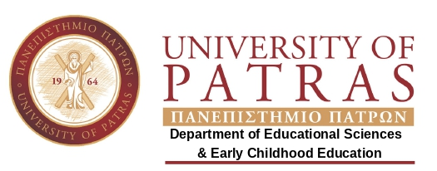Laboratory of Language and Literature | In collaboration with  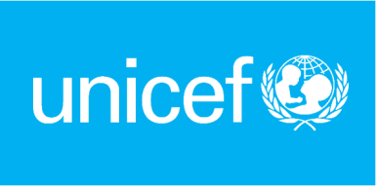  Under the patronage of
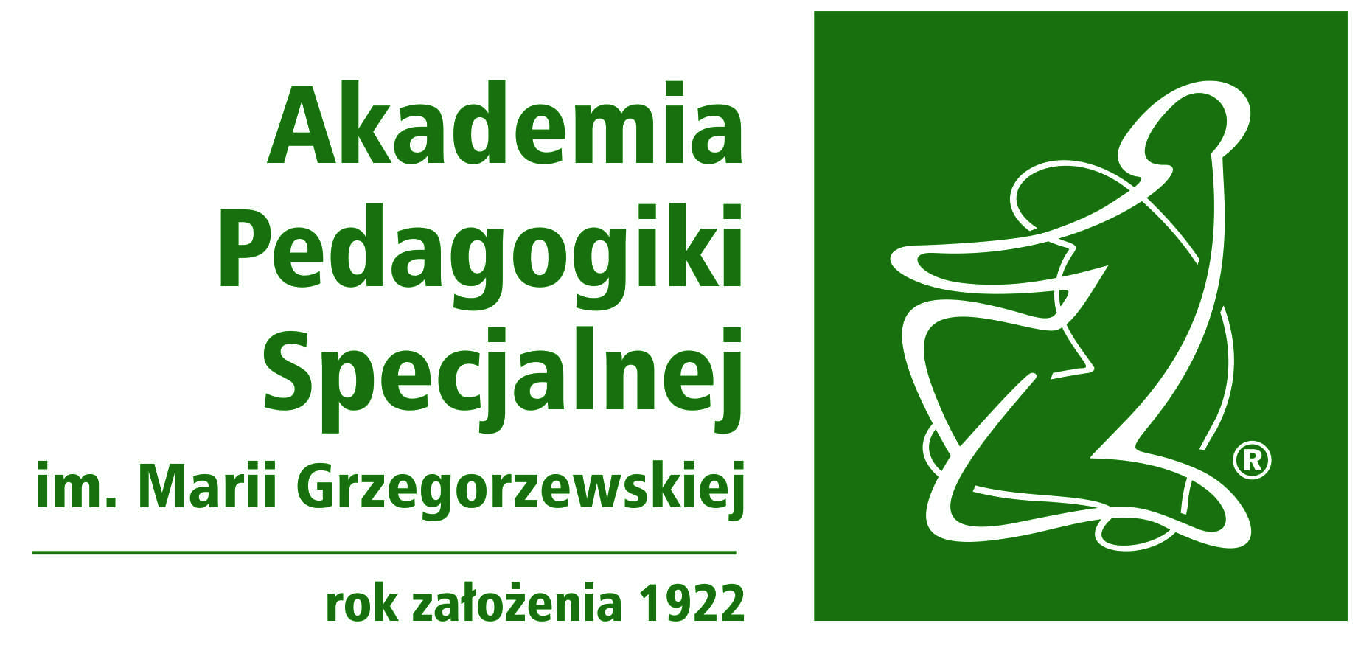

Coorganized with

International Conference: Janusz Korczak's Pedagogical Ideas: Framing the future of a respectful world for children and their rights

Date: 24 & 25 October 2019
Venue: UNIVERSITY OF PATRAS, Greece
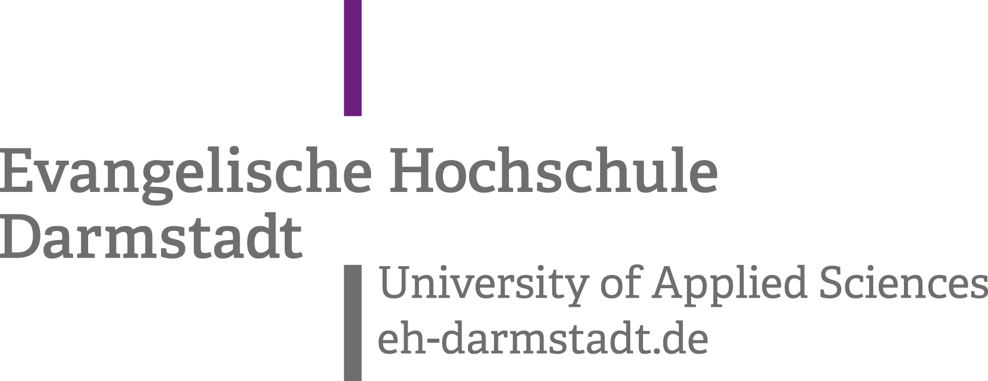  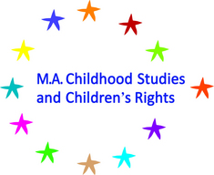  University of Applied Sciences Potsdam  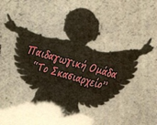  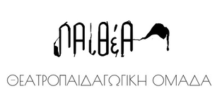 | Celebrating the 30th anniversary of the ratification of the UN Convention on the Rights of the Child in Autumn 2019, the Laboratory of Language and Literature of Department of Educational Sciences & Early Childhood Education has the honour to invite you to the International Conference devoted to Janusz Korczak's Pedagogical Ideas, which will be held on October 24-25, 2019 at the Patras University in Greece.  This is the first Conference on this topic held in Greece and we kindly ask you to spread the information to your networks and we are looking forward to meeting you in Greece!  Janusz Korczak (Henryk Goldszmit) was one of key child rights activists of the early 20th century. Nicknamed “The Old Doctor” - this Jewish-Polish pedagogue, doctor and author for children and adults promoted a concept of children’s rights that was ahead of the era he lived in. He treated the child as a subject of education, as a person whose rights are equal to those of the educator. In his publications and daily work with his pupils, he attempted to draw the world’s attention to the interdependencies between adults and children.  Janusz Korczak is a key figure both for children and the development of their rights in various parts of the world, and also for adults. Without his engagement and contribution, the codification of children’s rights in a humanistic paradigm in the international context might have taken a completely different turn. He compiled a catalogue of children’s rights,
stressing the importance of: the right to respect, the right to ignorance, the right to failure and tears, the right to secrets, the right to joy, the right to express one’s thoughts and emotions, the right to live in the present day and the right to die.
Janusz Korczak's pedagogical ideas are still central to the understanding of children and their right to rights. This is why, during the first conference in Greece devoted to Korczak and his ideas, we would like to discuss the Korczakian pedagogy oriented towards practice, respect for the child, understanding the child, dialogue and co-participation with the child that allows him to enjoy his agency (Bińczycka, 2009) and children’s rights approach connected to key challenges of the contemporary world through social, cultural and political perspectives.
AUDIENCE
This scientific conference is open to all interested participants. We particularly invite researchers, teachers and students, activists and policy-makers, staff members of NGOs and organizations who work on themes related to childhood and children’s rights.
The Conference will be attended by youth and adults and we cordially invite you to take an active part and to propose: presentations, workshops or posters on a relevant subject in accordance with your experience and activities.

If you wish to contribute, please, send your abstract no later than 25th of September 2019 [* NEW DATE] to korczak19@upatras.gr
The detailed program will be announced by the end of the first week of October 2019.

Registration fees: Adults: 40
Students: 15

Scientific and Organizing Committee

Nektarios Stellakis
Assistant Professor, Department of Educational Sciences and Early Childhood Education, University of Patras, Greece (nekstel@upatras.gr)

Anthi Karangeli
Consultant B΄_ Refugee Education
Cycle A’- Scientific Units for Methodology
Minority, Cross-cultural and Greek Diaspora Education, Prison Schools Unit
Institute of Educational Policy, Athens - Greece ( akarangeli@iep.edu.gr )

Prof. Dr. phil. Claudia Maier-Höfer
Evangelische Hochschule Darmstadt: University of Applied Sciences, Germany
(claudia.maier-hoefer@eh-darmstadt.de)

Dr Urszula Markowska-Manista
Assistant Professor, Faculty of Education, University of Warsaw, Poland
Program Director, MA Childhood Studies and Children's Rights, University of Applied Sciences Potsdam / Fachhochschule Potsdam, Germany
(u.markowska-ma@uw.edu.pl)

Dr Ewa Lewandowska
Early Education Department, affiliated researcher UNESCO/ Janusz Korczak Chair / The Maria Grzegorzewska University, Warsaw, Poland (ewalew@aps.edu.pl)

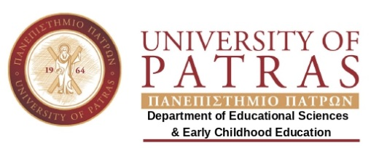Laboratory of Language and Literature | REGISTRATION FORM  Janusz Korczak's Pedagogical Ideas: Framing the future of a respectful world for children and their rights  24-25 OCTOBER 2019, PATRAS, GREECE

PARTICIPANT DETAILS
Last/ First Name:
Country:
e-mail:

REGISTRATION FEES
□ | Registration | 40,00 Euros
□ | Students | 15,00 Euros

PAYMENT DETAILS
□ | Bank Transfer  (with all bank charges pre-paid) | NATIONAL BANK OF GREECE  Account No: 229/ 54000232  IBAN: GR60 0110 2290 0000 2295 4000 232  SWIFT/ BIC code: ETHNGRAA  Account holder: ELKE UNIVERSITY OF PATRAS  - Details to be notified: KORCZAK2019/ Participant Name (e.g. KORCZAK2019/ Papadopoulos S.)  - Pease send us via e-mail to: korczak19@upatras.gr the receipt of the bank transfer

You are kindly requested to complete your registration by 30th of September 2019. You will receive your receipt at registration desk. In case you need an invoice, please, let us know.

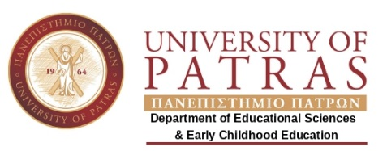Laboratory of Language and Literature | ABSTRACT SUBMISSION FORM  Janusz Korczak's Pedagogical Ideas: Framing the future of a respectful world for children and their rights  24-25 OCTOBER 2019, PATRAS, GREECE

Title
Name (s)
Affiliation
E-mail
Kind of participation | (choose one and delete the others)  - Individual paper presentation (15’ 7 5’ discussion)  - Panel discussion (at least 3 participants)  - Workshop (1-2 leaders share knowledge and expertise with a small group of participants)
Abstract
(maximum 350 words)
Submission | Send your abstract to korczak2019@upatras.gr by 10th of September 2019  * NEW DATE 25th of September 2019

